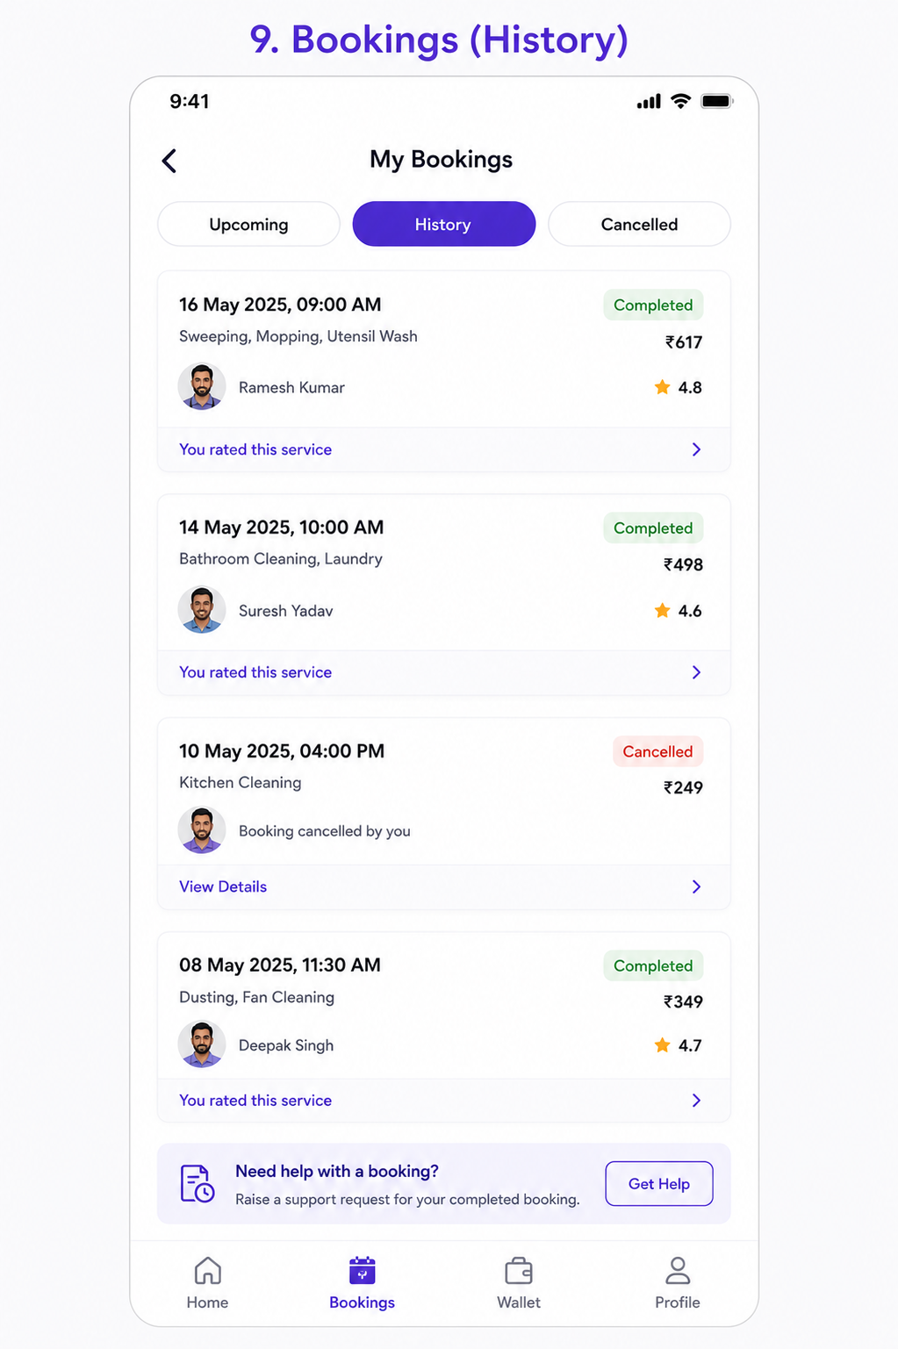User Story: My Bookings (History)
Epic: Booking History & Service Records
This screen allows customers to:
- View past bookings
- View upcoming bookings
- View cancelled bookings
- Access booking details
- View assigned professional
- Check service ratings
- Raise support requests
- Rebook services

Business Objective
Allow customers to:
✅ Track service history
✅ Increase repeat bookings
✅ Simplify support requests
✅ Improve customer retention
✅ Provide booking transparency
✅ Enable quick rebooking

Screen Sections
Tabs
Upcoming
Shows future scheduled bookings.
History
Shows completed bookings.
Cancelled
Shows cancelled bookings.

User Story 1: View Booking History
As a Customer
I want to see my previous bookings
So that I can review services I have used.
Acceptance Criteria
✅ Completed bookings displayed
✅ Sorted by latest booking first
✅ Service details displayed
✅ Booking amount displayed
✅ Professional details displayed

User Story 2: View Upcoming Bookings
As a Customer
I want to view future bookings
So that I know my scheduled services.
Acceptance Criteria
Display:
- Date & Time
- Services
- Booking Status
- Assigned Professional
- Amount

User Story 3: View Cancelled Bookings
As a Customer
I want to see cancelled bookings
So that I can track cancellation history.
Acceptance Criteria
Display:
- Cancellation date
- Cancellation reason
- Refund status
- Amount refunded

User Story 4: View Booking Details
As a Customer
I want to open a booking
So that I can view complete information.
Acceptance Criteria
Click booking card.
Open Booking Details page.
Display:
- Booking ID
- Services
- Date
- Time
- Address
- Professional
- Payment Details
- Invoice

User Story 5: View Professional Information
As a Customer
I want to know who completed my service
So that I can identify the professional.
Acceptance Criteria
Display:
- Professional Name
- Profile Photo
- Rating
- Service Status

User Story 6: View My Ratings
As a Customer
I want to see reviews I submitted
So that I can track my feedback.
Acceptance Criteria
Display:
You rated this service
Customer can open submitted review.

User Story 7: Raise Support Request
As a Customer
I want to get help regarding a booking
So that issues can be resolved.
Acceptance Criteria
Get Help button visible.
Support ticket created.
Booking automatically attached.

User Story 8: Rebook Previous Service
As a Customer
I want to rebook a previous service
So that I can save time.
Acceptance Criteria
Rebook option available.
Previous services pre-selected.
Customer chooses date/time only.

Functional Requirements
Booking Card Information
Mandatory Fields
Field | Required
Booking Date | Yes
Booking Time | Yes
Services | Yes
Status | Yes
Amount | Yes
Professional Name | Yes
Professional Photo | Yes
Rating | Yes (Completed Only)

Booking Status Types
Upcoming
Scheduled
Assigned
On The Way
Arrived
In Progress

History
Completed

Cancelled
Cancelled by Customer
Cancelled by Professional
Cancelled by System

Sorting Logic
Default sorting:
Latest Booking
↓
Oldest Booking

Search Functionality
Customer can search by:
- Booking ID
- Professional Name
- Service Name
- Date

Filter Functionality
Filter By Status
- Completed
- Cancelled
- Upcoming
Filter By Date
- Today
- Last 7 Days
- Last 30 Days
- Custom Range

Booking Details Workflow
Booking History
↓
Booking Card
↓
View Details
↓
Booking Detail Screen

Support Workflow
Booking History
↓
Get Help
↓
Issue Selection
↓
Support Ticket
↓
Resolution

Test Cases
TC-01 Load History Screen
Expected Result
History bookings displayed successfully.

TC-02 Switch To Upcoming
Action
Click Upcoming tab.
Expected Result
Upcoming bookings displayed.

TC-03 Switch To Cancelled
Action
Click Cancelled tab.
Expected Result
Cancelled bookings displayed.

TC-04 View Booking Details
Action
Click booking card.
Expected Result
Booking details page opens.

TC-05 Verify Booking Information
Expected Result
Correct:
- Date
- Time
- Services
- Amount
Displayed.

TC-06 Verify Professional Details
Expected Result
Professional information displayed correctly.

TC-07 View Submitted Rating
Action
Click:
You rated this service
Expected Result
Submitted review displayed.

TC-08 Raise Support Request
Action
Click Get Help.
Expected Result
Support form opens.

TC-09 Empty History
Action
No bookings available.
Expected Result
Display:
No bookings found.

TC-10 Search Booking
Action
Search by service name.
Expected Result
Matching bookings displayed.

TC-11 Filter By Date
Action
Select Last 30 Days.
Expected Result
Relevant bookings displayed.

TC-12 Rebook Service
Action
Click Rebook.
Expected Result
Previous services loaded.

TC-13 Open Cancelled Booking
Action
Click cancelled booking.
Expected Result
Cancellation details shown.

TC-14 Refresh Screen
Action
Pull to refresh.
Expected Result
Latest bookings loaded.

TC-15 Pagination
Action
Scroll to bottom.
Expected Result
Next records loaded.

Edge Cases
EC-01 Deleted Professional
Scenario
Worker account deleted.
Expected Result
Display:
Professional unavailable
Booking remains visible.

EC-02 Partial Refund
Scenario
Cancelled booking partially refunded.
Expected Result
Refund amount shown.

EC-03 Booking Dispute
Scenario
Customer raises complaint after completion.
Expected Result
Ticket linked to booking.

EC-04 Large Booking History
Scenario
1000+ bookings.
Expected Result
Pagination works properly.

EC-05 Offline Mode
Scenario
Internet unavailable.
Expected Result
Cached bookings shown.

APIs Required
Get Bookings
GET /bookings?status=completed

Response:
[
{
"bookingId":"BK1001",
"date":"2025-05-16",
"amount":617,
"status":"COMPLETED"
}
]

Get Booking Details
GET /booking/BK1001

Response:
{
"services":[
"Sweeping",
"Mopping"
],
"professional":"Ramesh Kumar"
}

Raise Support Ticket
POST /support/create

{
"bookingId":"BK1001",
"issue":"Service quality issue"
}

Notifications
Upcoming Booking Reminder
Your booking is scheduled tomorrow at 09:00 AM.
Support Ticket Created
Your support request has been created successfully.
Refund Processed
Refund of ₹249 has been processed.

Analytics Events
Track:
- History Viewed
- Upcoming Viewed
- Cancelled Viewed
- Booking Details Viewed
- Support Requested
- Rebook Clicked
- Search Used
- Filter Applied

Admin Features Required
Booking Management
- View customer booking history
- View booking details
- View cancellation reasons
- View refunds
- View complaints
Support Management
- Booking-linked tickets
- Escalations
- Refund approvals
- Service quality investigations

Navigation Flow
Home
↓
My Bookings
↓
Upcoming / History / Cancelled
↓
Booking Details
↓
Invoice / Review / Support
↓
Rebook Service
Additional Business Rules
Completed Booking
- Show invoice download.
- Show submitted review.
- Allow support request for 7–30 days (configurable).
Upcoming Booking
- Allow reschedule.
- Allow cancellation based on policy.
Cancelled Booking
- Show refund status.
- Show cancellation reason.
Loyalty Opportunity
For repeat customers:
- Show "Book Again" button.
- Recommend frequently booked services.
- Offer loyalty discounts and subscription plans.
This screen becomes the customer's permanent service record and serves as the foundation for rebooking, support, invoicing, refunds, loyalty programs, and customer lifetime value tracking.

